Joseph Goyette
12 Goff Road, Norton, Massachusetts 02766
508-212-7932
mister.goyette@gmail.com | www.thecaptainscask.com
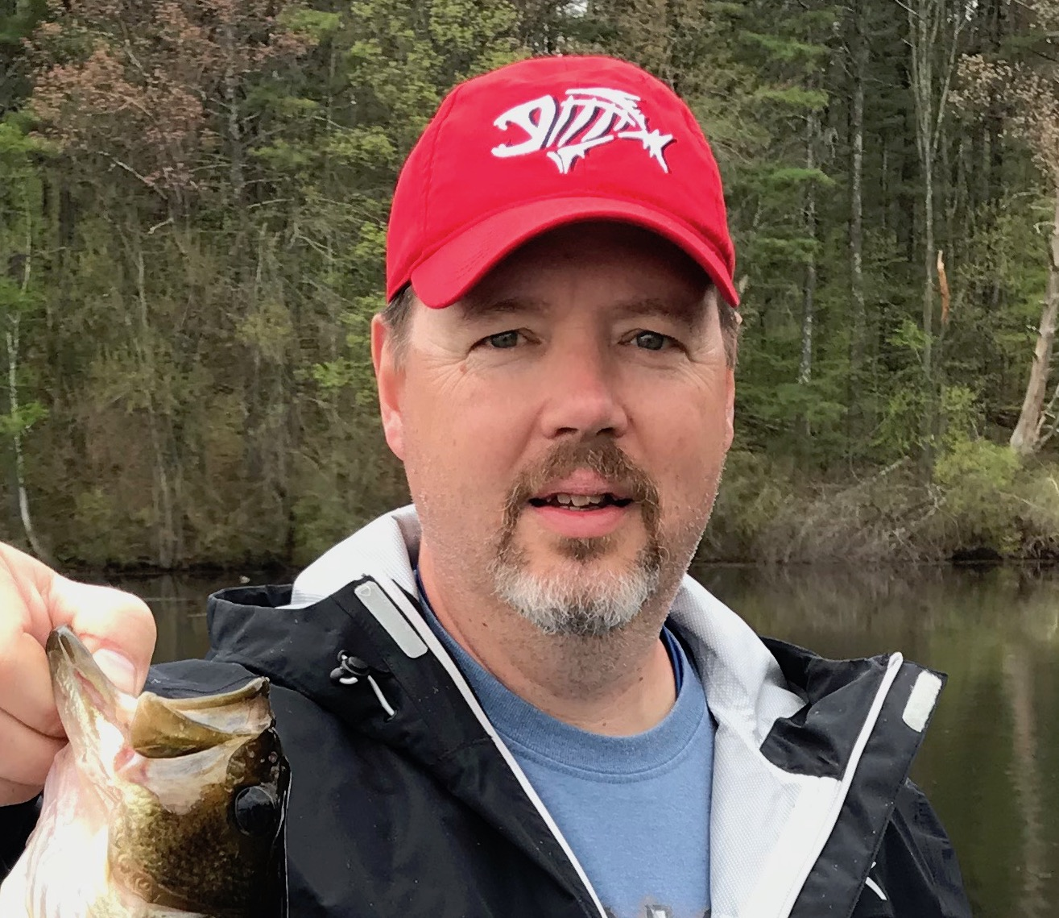

Professional Summary
- Experienced, diligent, responsible information technology leader possessing extensive managerial & technical skills

- Successful builder, coach, motivator & leader of high performing technical operations teams

- Ability to balance the daily information technology disruptions & crises while staying focused on the achievement of long term goals

- Always ready for new learning, challenges & responsibilities

Education

Northeastern University, Boston, Massachusetts
1988 ▪ Bachelor of Science in Computer Science

Experience

Director, Hosting Operations
▪ March 2015 – Present
Harris CareTracker ▪ www.harriscaretracker.com
Harris CareTracker is a healthcare software development company providing software solutions for the medical practice management, electronic health/medical record & revenue cycle management markets. The software solutions are sold and delivered to customers as fully hosted, software-as-a-service (SaaS) applications.
- CareTracker – www.caretracker.com
- Digichart – www.digichart.com
- Amazing Charts – www.amazingcharts.com
- Clinix – www.clinixmis.com
Responsible for the managerial, technical & operational direction & oversight for each of those SaaS applications.
- Managerial
  - Vendor management, Forecasting, Planning, Project Management
  - Change management, issue & event management
  - Mergers & Acquisitions
    - Due diligence of potential new product acquisitions
    - Integration of newly acquired companies & products
  - Team
    - 8 direct reports
      - Senior Manager Cloud Operations
      - Manager, Technical Operations
      - Database Administrators
      - Systems & Security Engineers
    - Goal setting, guidance, motivation, direction, coaching, motivation
    - My team refers to me as “the asker of questions”… I don’t tell my team how to do things… I trust their technical capabilities implicitly. Rather, I ask questions that may guide them to better/alternative solutions and/or cause them to look at the bigger picture. “Have you considered … ?”
- Operational
  - Monitoring, Capacity Planning, 7x24x365 Operations, Disaster Recovery, Process
- Technical
  - Vast experiences with & knowledge of legacy technologies
  - Stay abreast of new technologies, techniques & architectures
- Security
  - Protection of PHI data, HIPAA, HITRUST, Compliance, Policies & procedures

Data Center Manager
▪ May 2010 – March 2015
Optum ▪ www.optum.com
Optum CareTracker is a family of cloud-based products and services that simplify administration of physician practices and improve care by enabling physicians to spend more time with patients. Today, more than 10,000 healthcare providers use CareTracker nationwide.
- Management
  - Reported directly to the CIO & VP of Engineering
  - Managed a small team comprised of one systems administrator, one network administrator and one database administrator
  - Responsible for departmental and employee goals
  - Monthly capacity planning & availability reporting
  - Oversight of the change management, event management & issue tracking processes
  - Security & Compliance
  - Vendor management
  - Senior technical liaison between the CareTracker product teams and various Optum technical and executive teams
  - Run daily Hosting Operations meetings to review open issues, new issues, action plans, upcoming deployments & scheduled maintenance
- Technical
  - Responsible for the design, build, management & operation of Optum’s 7x24x365, software-as-a-service CareTracker application
  - Responsible for the design, build, management & operation of CareTracker’s disaster recovery planning & infrastructure. The disaster recovery infrastructure was built in Aurora, Colorado as a like-for-like copy of our primary hosting infrastructure located in Andover, MA
  - Responsible for the design, build, management & operation of CareTracker’s Development & QA infrastructure
On December 24th, 2014. Optum sold the CareTracker product to Harris Computer.

Manager, Systems Administration
▪ May 2009 – May 2010
Nuance Communications ▪ www.nuance.com
In May of 2009, Nuance Communications purchased eScription.
Over the course of the following year, eScription’s systems administration teams and data centers were gradually merged with Nuance’s own.
In addition to overseeing and assisting with the transition process, I was also responsible for:
- Management and oversight of the annual capacity planning, forecasting & budgeting processes
- Management of vendors, RFP’s, quotes, purchasing and associated technology acquisition processes
- Serving as the technical liaison between my team and the various sales, product management and engineering teams at Nuance
- Reviewing technical requirements for new customer initiatives to validate technical correctness as well as operational capacity

Manager, Systems Administration
▪ 2002 –2009
eScription ▪ www.escription.com
eScription was a pioneer in Computer Aided Medical Transcription. eScription provided those CAMT services via a software-as-a-service model. The premise that “it is faster to edit than it is to type” was supported by the use of advanced speech recognition technologies which produced 85%-95% correct initial drafts of medical transcriptions.
- 12th employee of the company and 1st dedicated systems management person.
- Management
  - Reported directly to both of the two Co-CEOs
  - Part of the corporate leadership team that consisted of myself, four of my peers and the 2 Co-CEOs
  - Defined and led yearly company goals as well as my own departmental goals
  - Represented eScription and presented in front of customers at yearly user conferences
  - Developed & Lead a team of 20 systems, network & database administrators, including 2 managers
    - Hiring, mentoring, coaching, developing, managing
  - Responsible for an annual operations budget of $4 million
- Technology
  - Responsible for the design, build, management & operation of eScription’s 7x24x365, software-as-a-service computer aided medical transcription services platform.
    - Relocation from a jam-packed, overheating office closet to a small office data room and then again to a professionally managed data center facility as growth and needs dictated
    - Introduction of standardization and consistent practices across all IT functions
    - Grew infrastructure from a dozen servers to over a thousand Linux and Windows servers
  - Responsible for the design, build, management & operation of eScription’s disaster recovery planning & infrastructure
  - Responsible for the design, build, management & operations for all aspects of eScription’s internal corporate networks
    - Supported 200+ end users – laptops, desktops, email, backups, security, encryption
    - Development & QA networks supporting 40+ developers
- Helped transform eScription from a small, private 12-person company to a public, 200+ person company providing computer aided medical transcription services to hundreds of clients. eScription was sold to Nuance Communications in 2009 for $400 million

Director of Technical Operations & IT
▪ 1999 –2002
FairMarket ▪ www.fairmarket.com
FairMarket was an application service provider that offered private-label, hosted auction services enabling companies and internet portals to auction off excess inventory. In March of 2000, FairMarket went public.
- 10th employee of the company and 1st dedicated systems management person.
- Responsible for the design, build, management & operation of FairMarket’s 7x24x365, software-as-a-service, private-label (business-to-consumer) auction services platforms
  - FairMarket’s primary auction services platform was based in the United States
  - In 2002, lead the build out of a FairMarket auction services platform in the United Kingdom. FairMarket’s UK-based customers wanted a locally hosted platform
- Responsible for the design, build, management & operations for all aspects of FairMarket’s internal corporate networks
  - Supported 250+ end users – laptops, desktops, email
  - Development & QA networks supporting 50+ developers
- Developed & Lead a team of 12 systems & network administrators
  - Hiring, mentoring, coaching, developing, managing
- Helped grow FairMarket from a small, private 10-person company to a public, 250+ person company providing private-label auction services for hundreds of customers

Technical Consultant, Oracle
▪ 1998 –1999
Obtech ▪ www.obtech.com

Webmaster, DBA ▪ 1997 –1998
The Monster Board ▪ www.monster.com

Principal Software Engineer
▪ 1988 - 1997
Digital Equipment Corporation▪ www.digital.com
Skills & Keywords

- Microsoft Windows
  - Server 2003
  - Server 2008
  - Server 2012
  - Server 2016
  - Active Directory
- Microsoft Azure
- Microsoft SQL Server
- Oracle
  - 10g, 11, 12c
- Linux
  - Red hat, CentOS, Fedora
  - Oracle Linux
- Apple
  - MacOs, Ios
- Vmware
  - Esxi, Nsx
- Languages
  - Perl, PHP, C, C++, Java, Vbscript, Powershell, MySQL, Pl/SQL, T/SQL
- Vendors
  - EMC, Network Appliance, VMWare, Cisco, Juniper, PRTG, Nagios, Zenoss
- Other
  - DNS, SMTP, SSH, FTP, HTTP, HTTPS, SSL, TLS, SNMP, IIS, Apache, Tomcat, Azure, AWS, Agile, HIPAA, HITRUST, HiTech, NIST, Virtualization, SAAS, IAAS
  - Leadership, Compliance, Coaching, Mentoring, Management, Security, Cloud

